Chat GPT

I used AI in one area, it provided as a great guideline in helping me to understand the problem and almost as a teacher when conducting test cases.

The first time I used AI was to help distinguish what type of testing unit testing looks like in OOP. This was very important to allow me to gain an in-depth understanding of how the testing should look and allowed me to understand whether the tests I was conducting were reasonable. Chat gpt was the AI used for this question, although the AI itself did not give me the exact answer I was looking for I compared my notes to the answer and tried to find ways to conduct more tests and ensure my system was as robust as possible.

Testing outcomes

**AnnualPlan**

Please see the following screenshots which confirm the annual plan test cases have been ran successfully with the code in order to ensure the class is robust. These tests are a variety of integration and unit tests in order to ensure the system works securely. The annual plan class holds the halls and months primarily for each exhibit which then contains an array list of artifacts a unique id and a name and description.

AnnPlanTC01 ensures that that the annual plan if created will have 12 months and three halls as specified in the overview

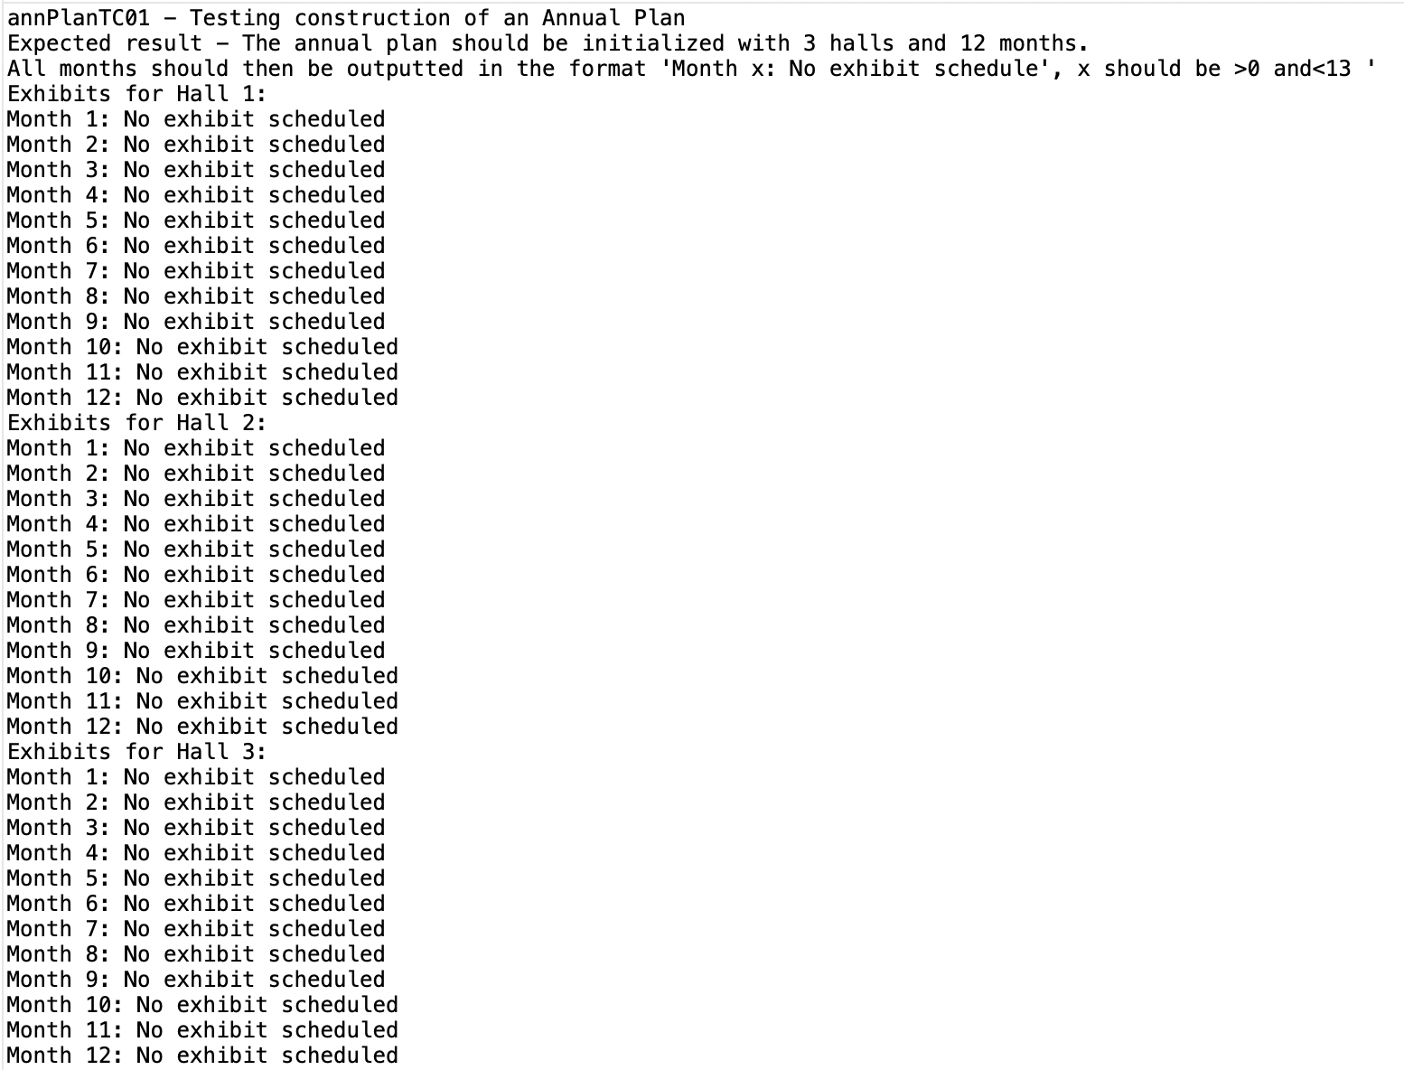

AnnPlanTC02 ensures that if the user tries to display an invalid hall number then simply an error message should appear as you can see.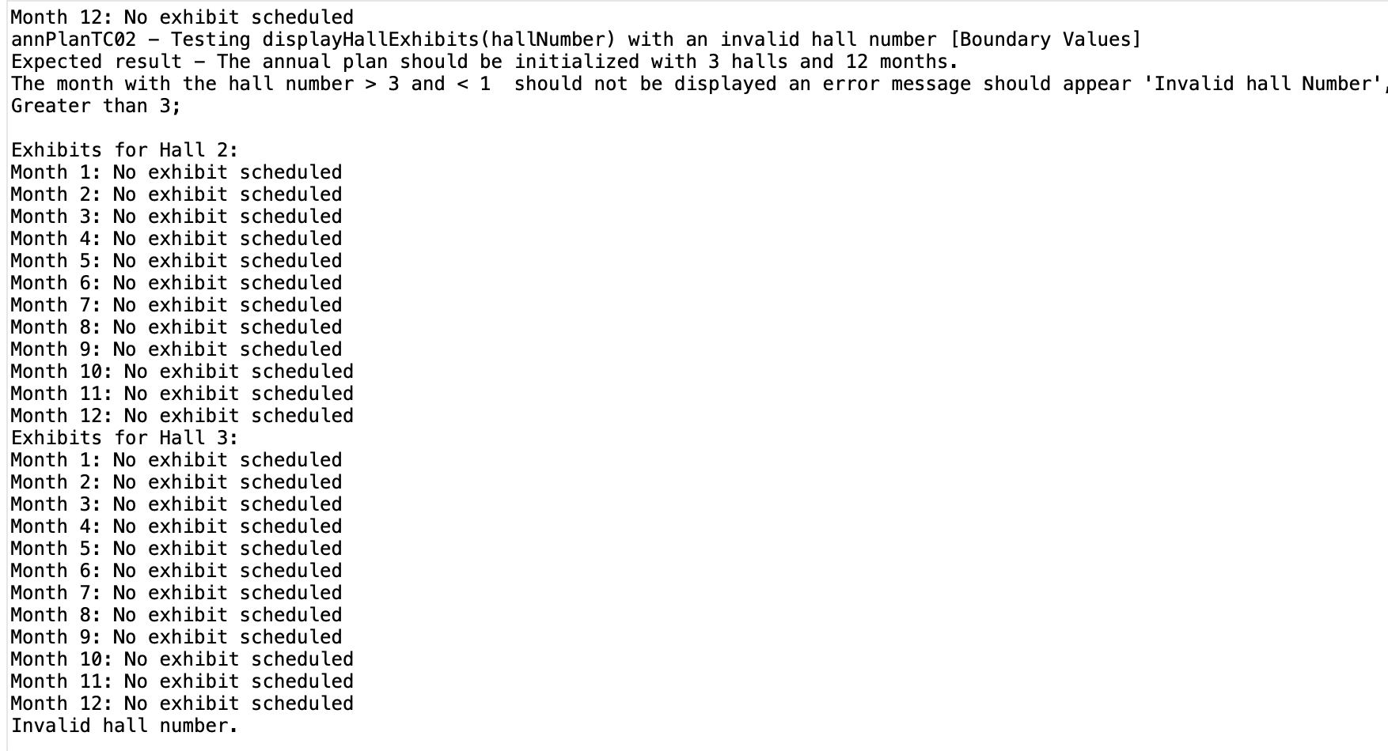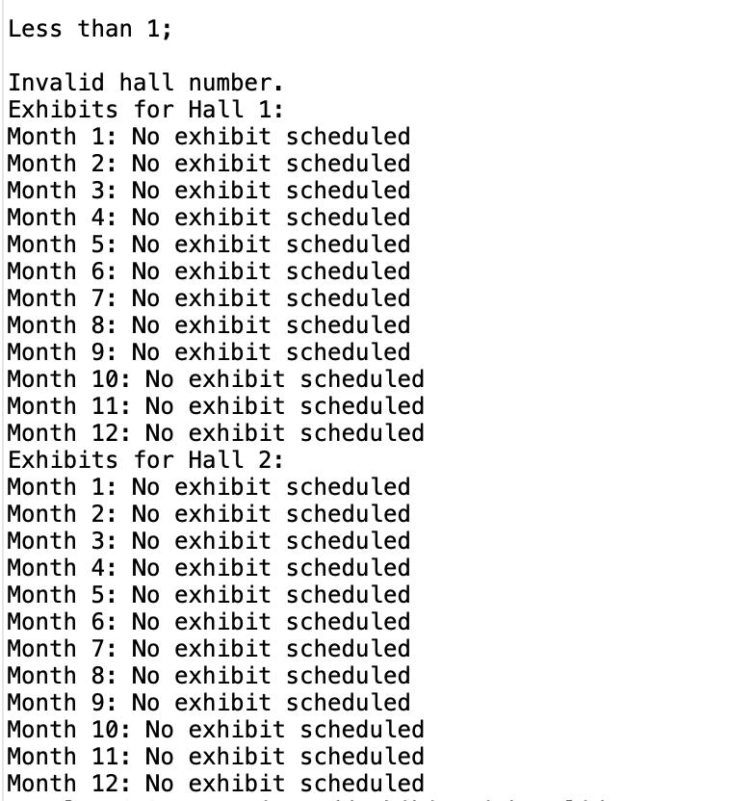

AnnPlanTC03-05 all test the add exhibit with valid and invalid parameters passed in to see how the system deals with invalid parameters passed in.

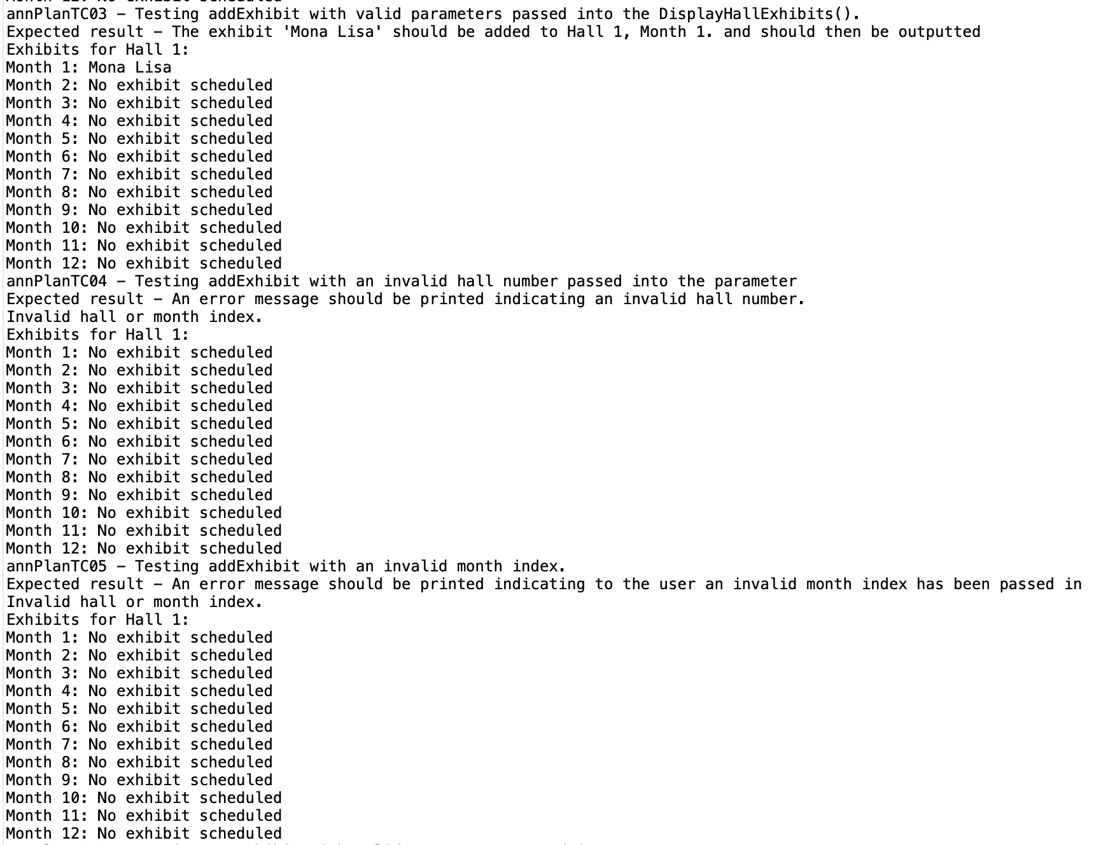

AnnPlanTC06-07 tests the get exhibit with valid and invalid parameters

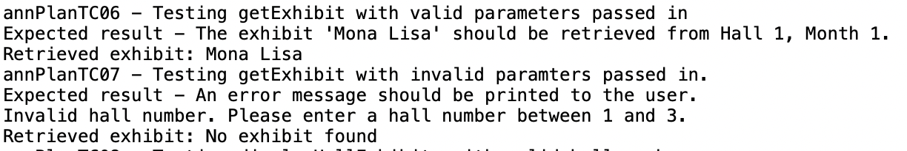

AnnPlantc08 tests the display hall exhibits. 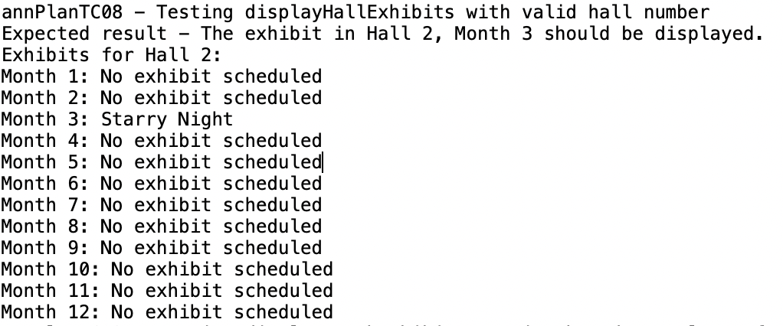

AnnPlanTC09 tests the display month exhibits

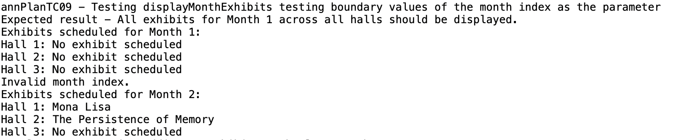

AnnPlanTC10-11 tests adding exhibits to first and last month within a hall

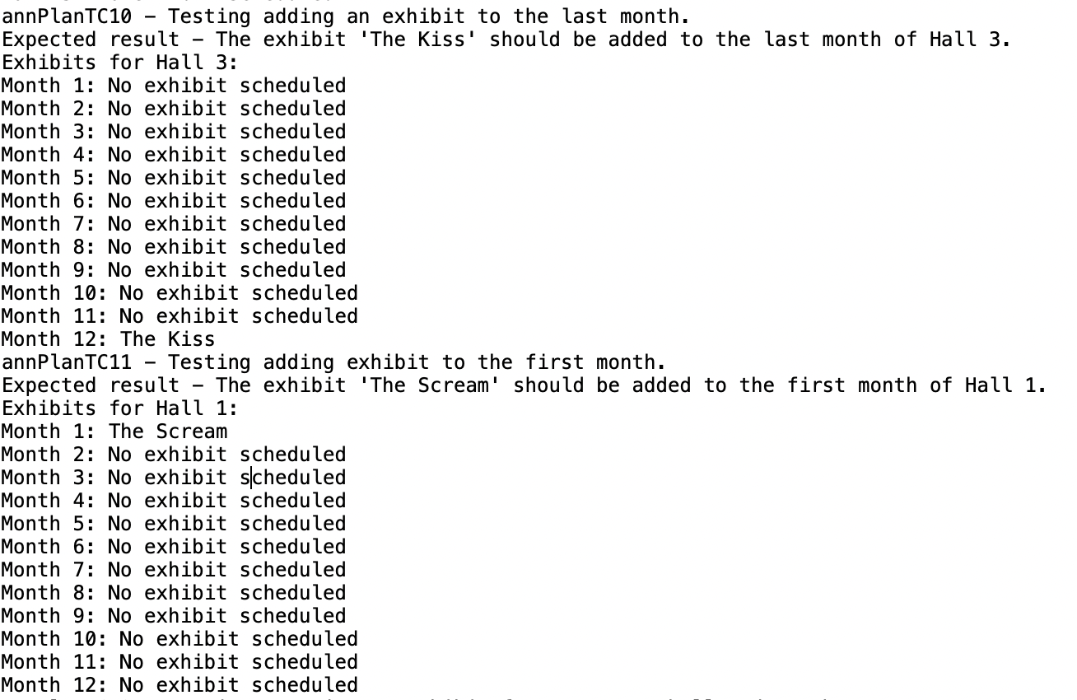

AnnPlanTC12 tests removing an empty hall and month

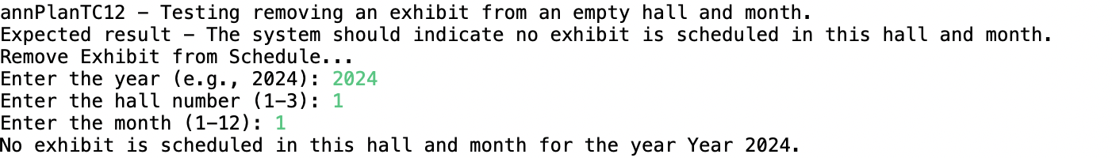

AnnPlanTC13 and 14 test adding over a month and adding an invalid exhibit

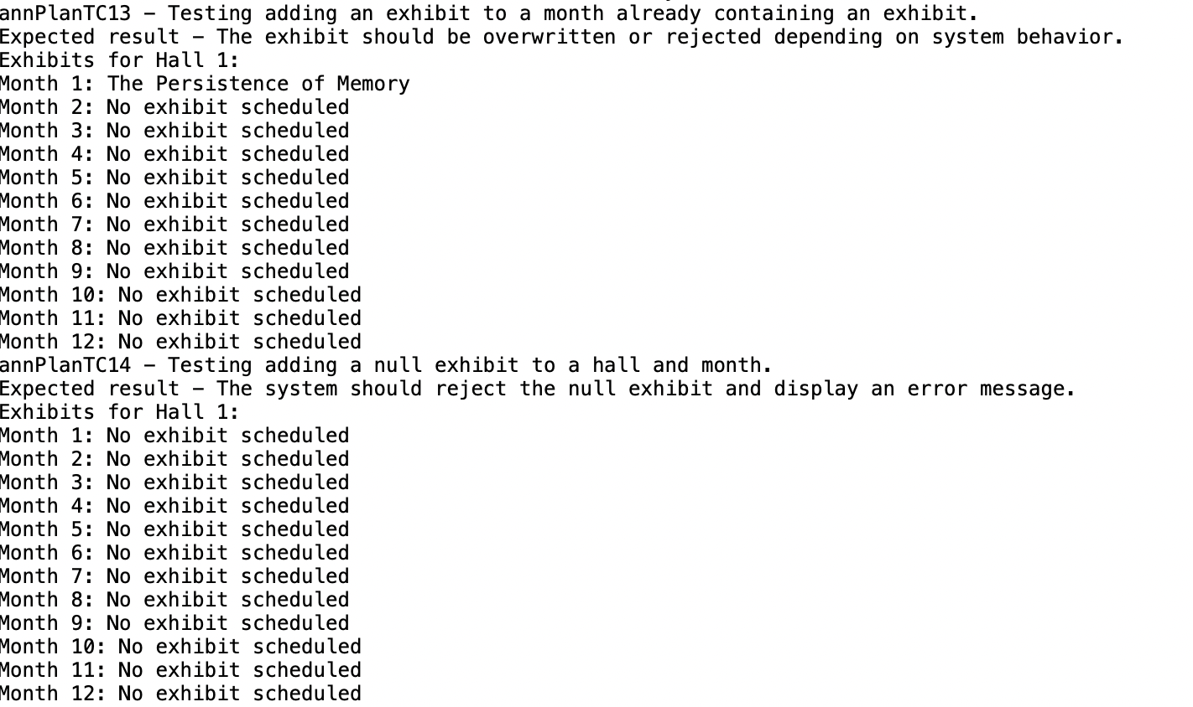

AnnPlanTC15 ensures that only a valid number is entered

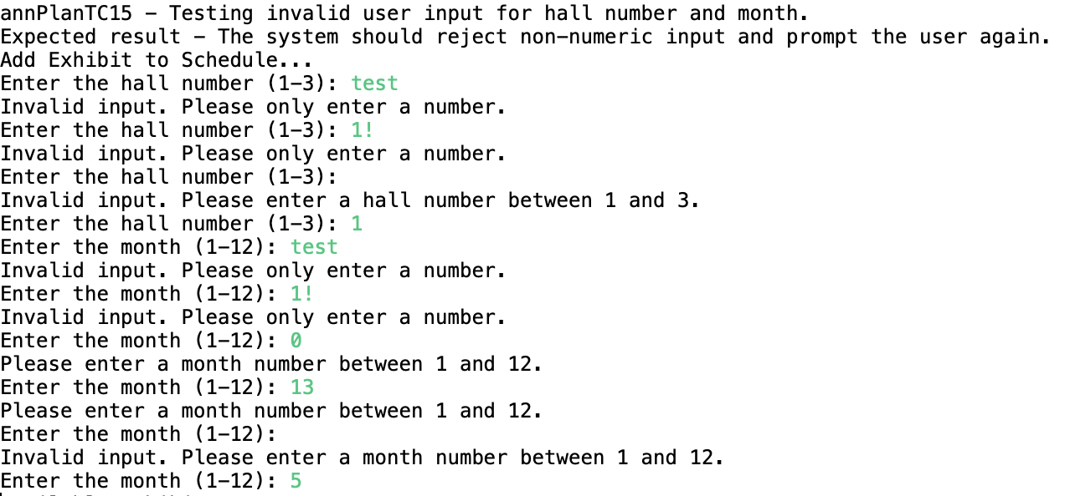

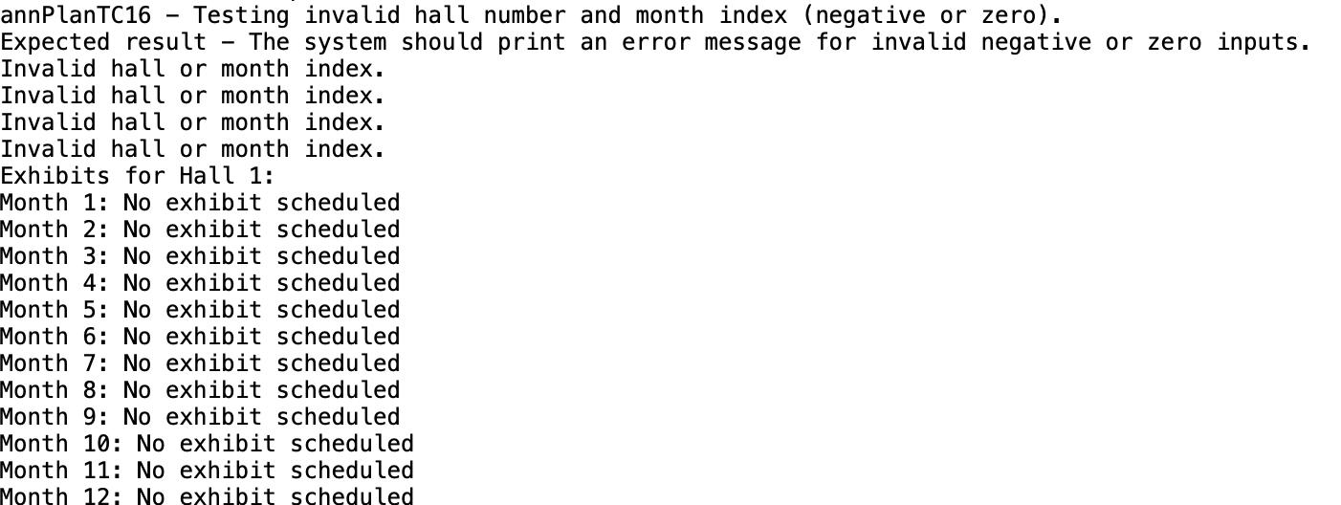

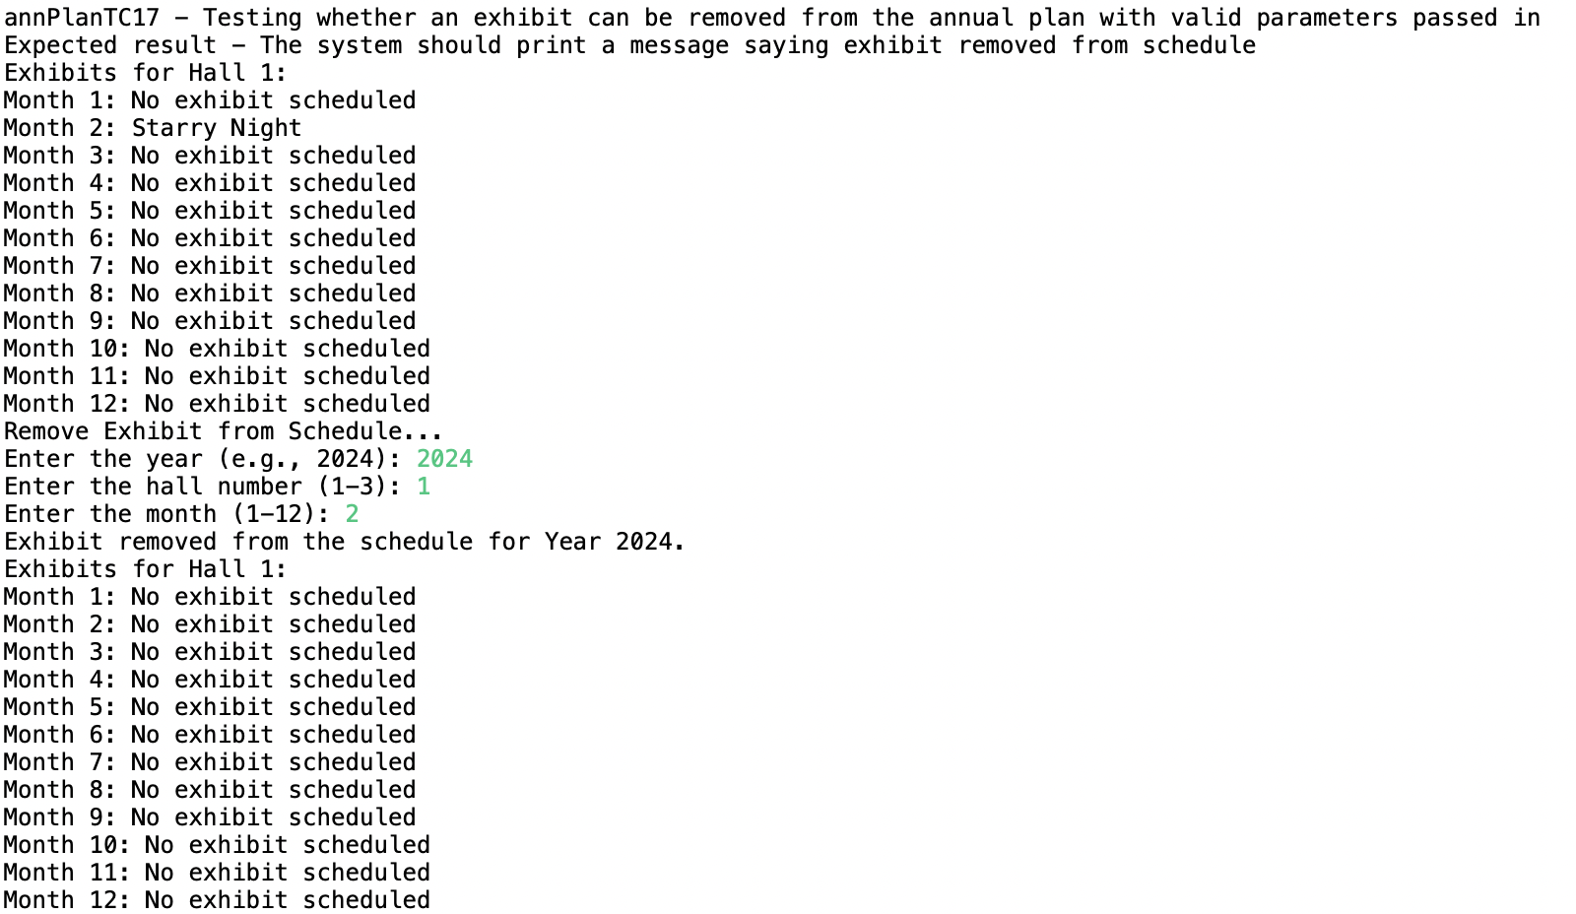

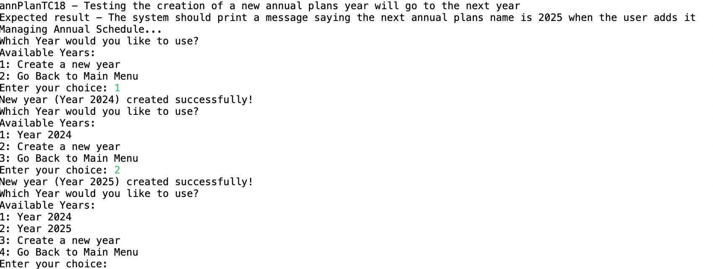

Artifact Tests

The artifact class contains a lot of methods and hence requires some heavy testing to ensure the ‘foundation’ of the system is working. The first three screenshots (test 1 – to 15) all test the creation of an Artifacts instance.

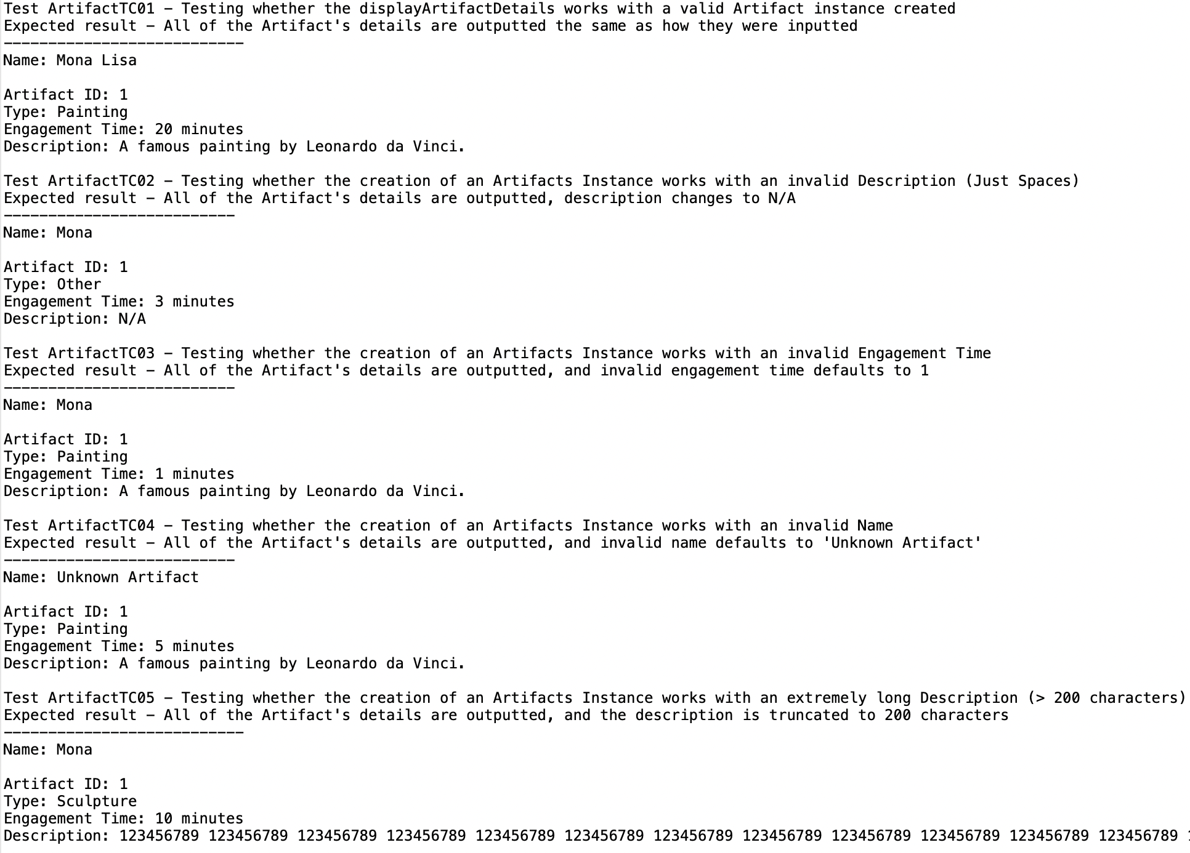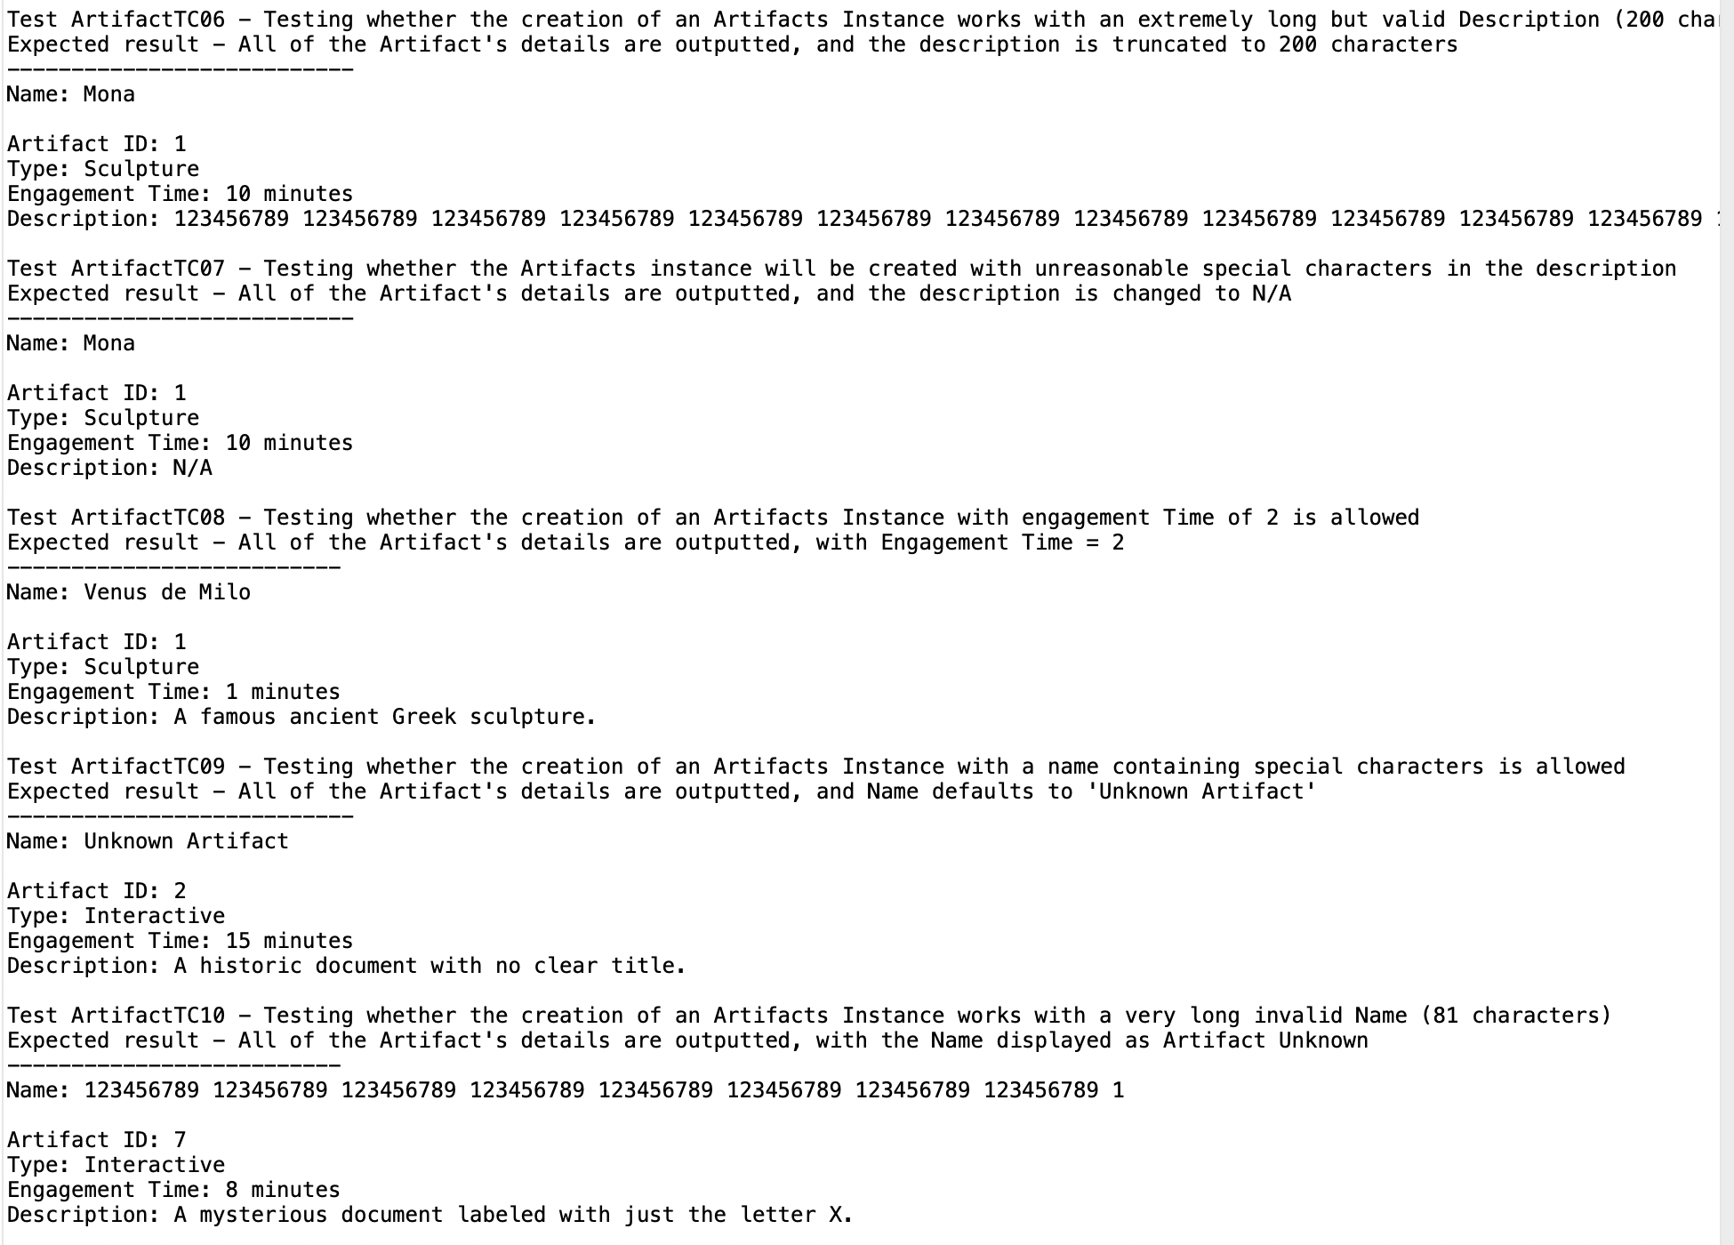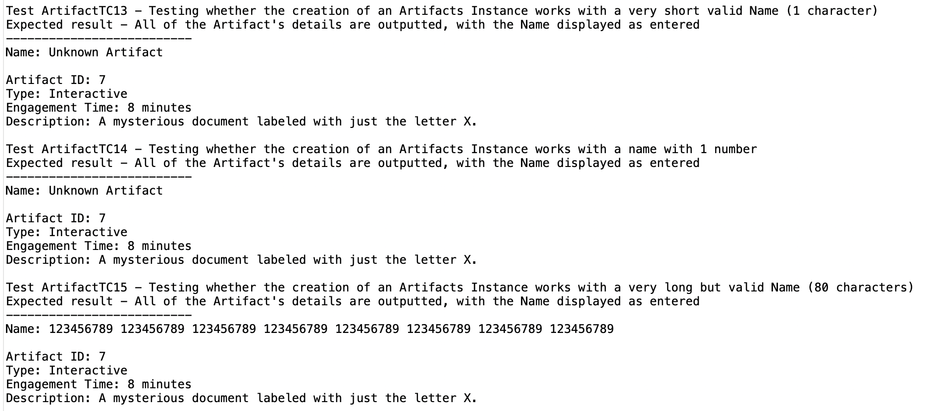

ArtifactTC16 tests the removal of an artifact with a valid id, (valid parameter)

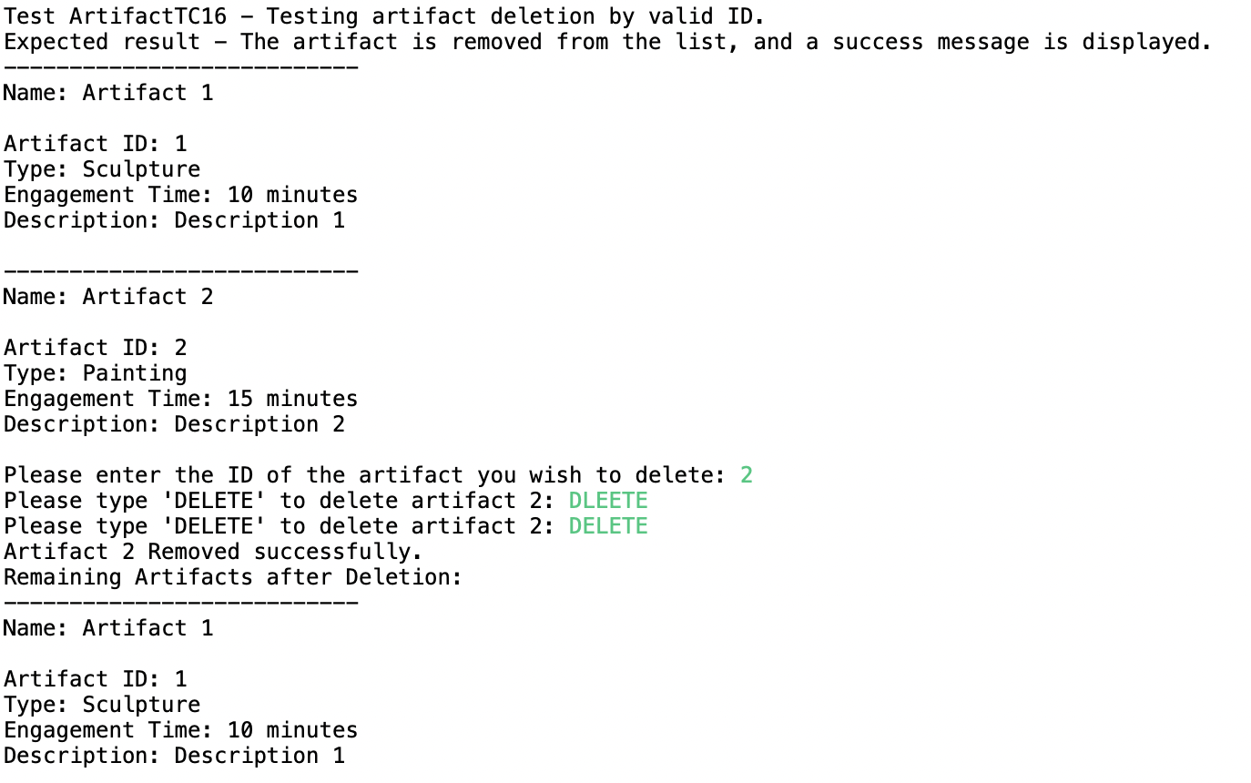

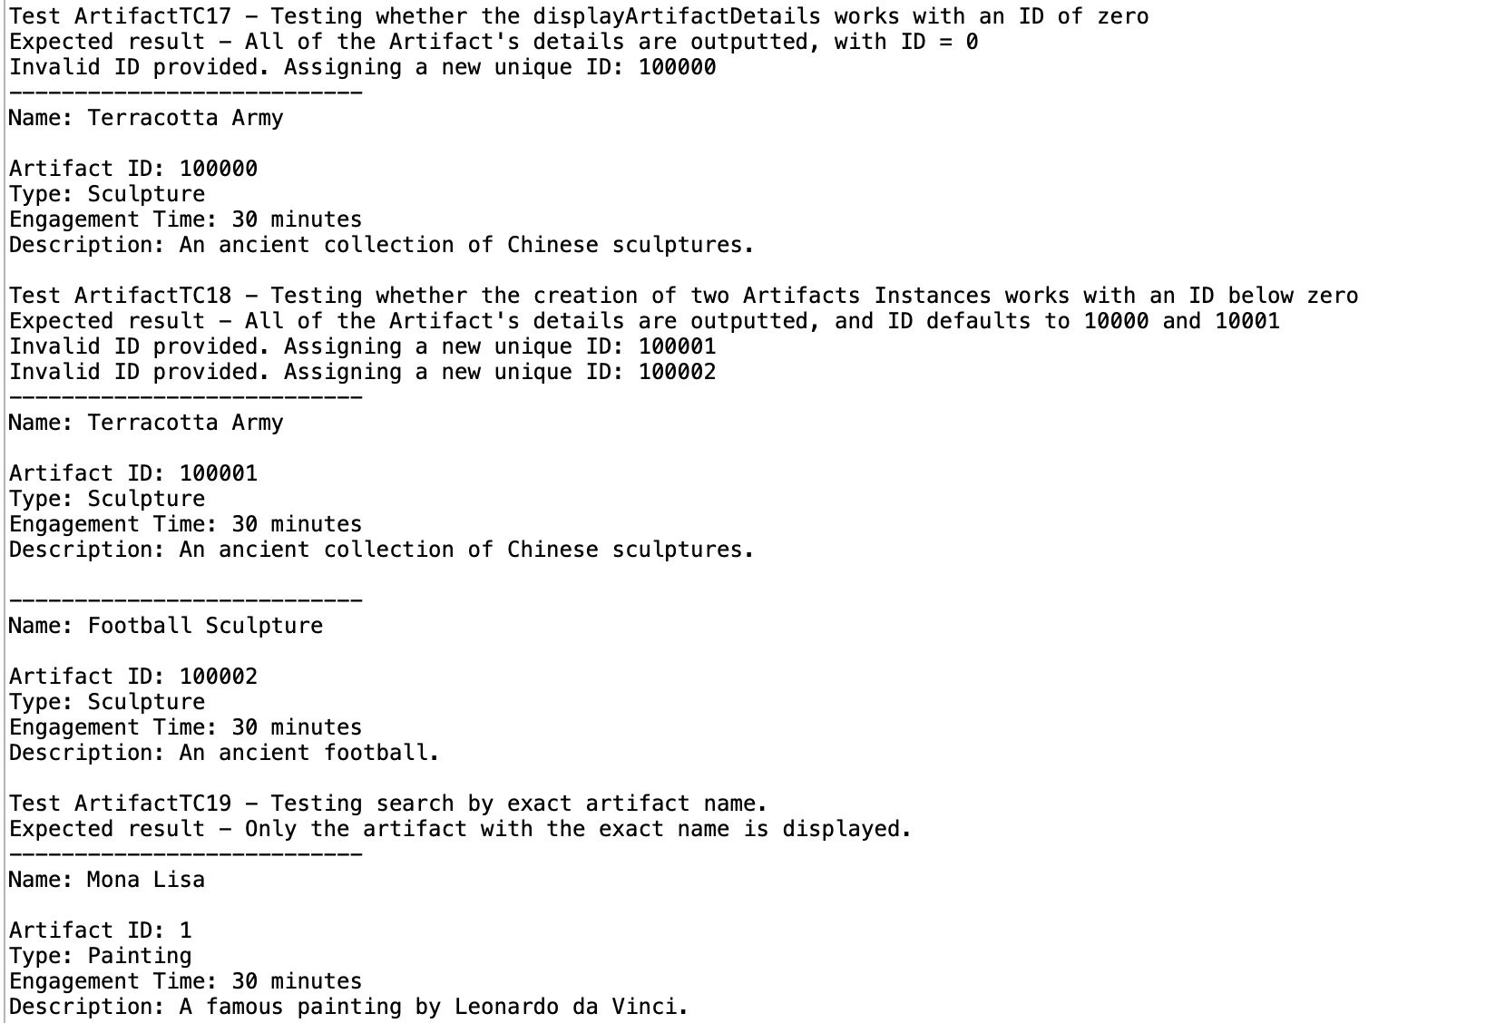

The last few screenshots of tests are very self explanatory and do not need more text than what is discussed than the title and expected result. If you read the sub test information I believe these tests are also well explained.

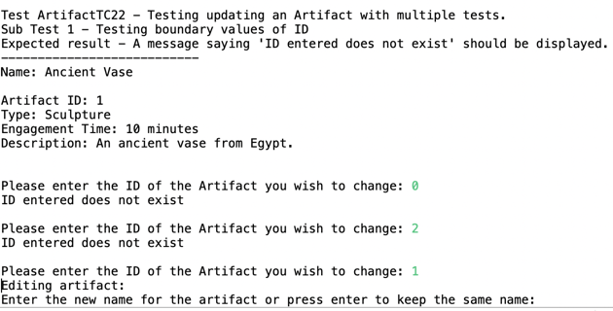

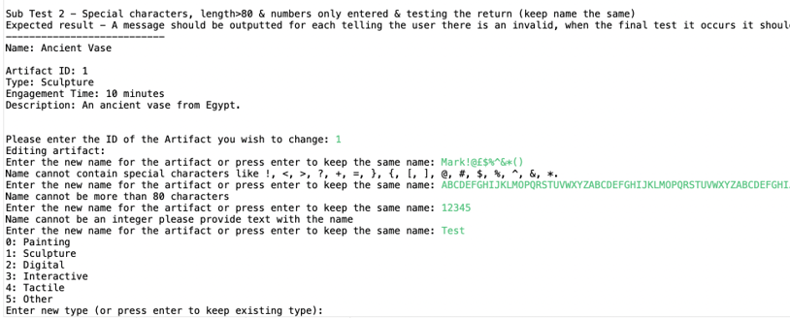

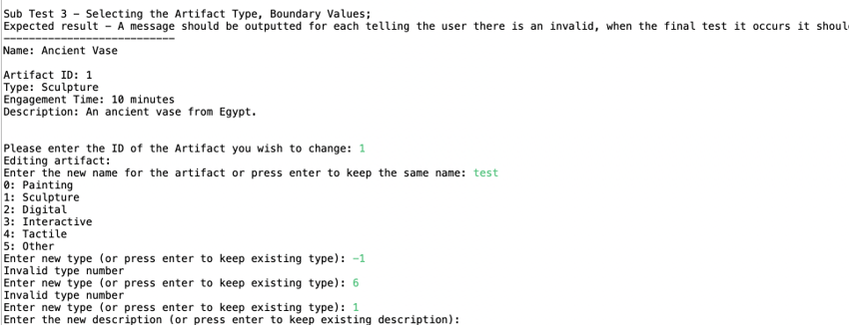

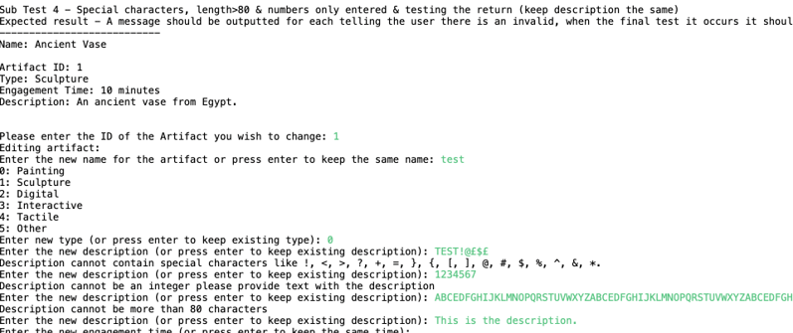

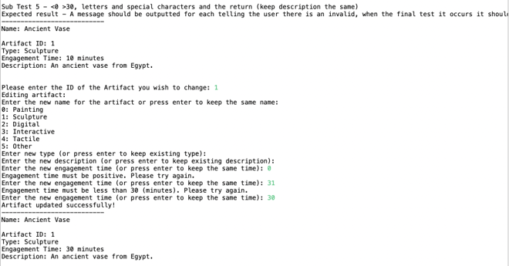

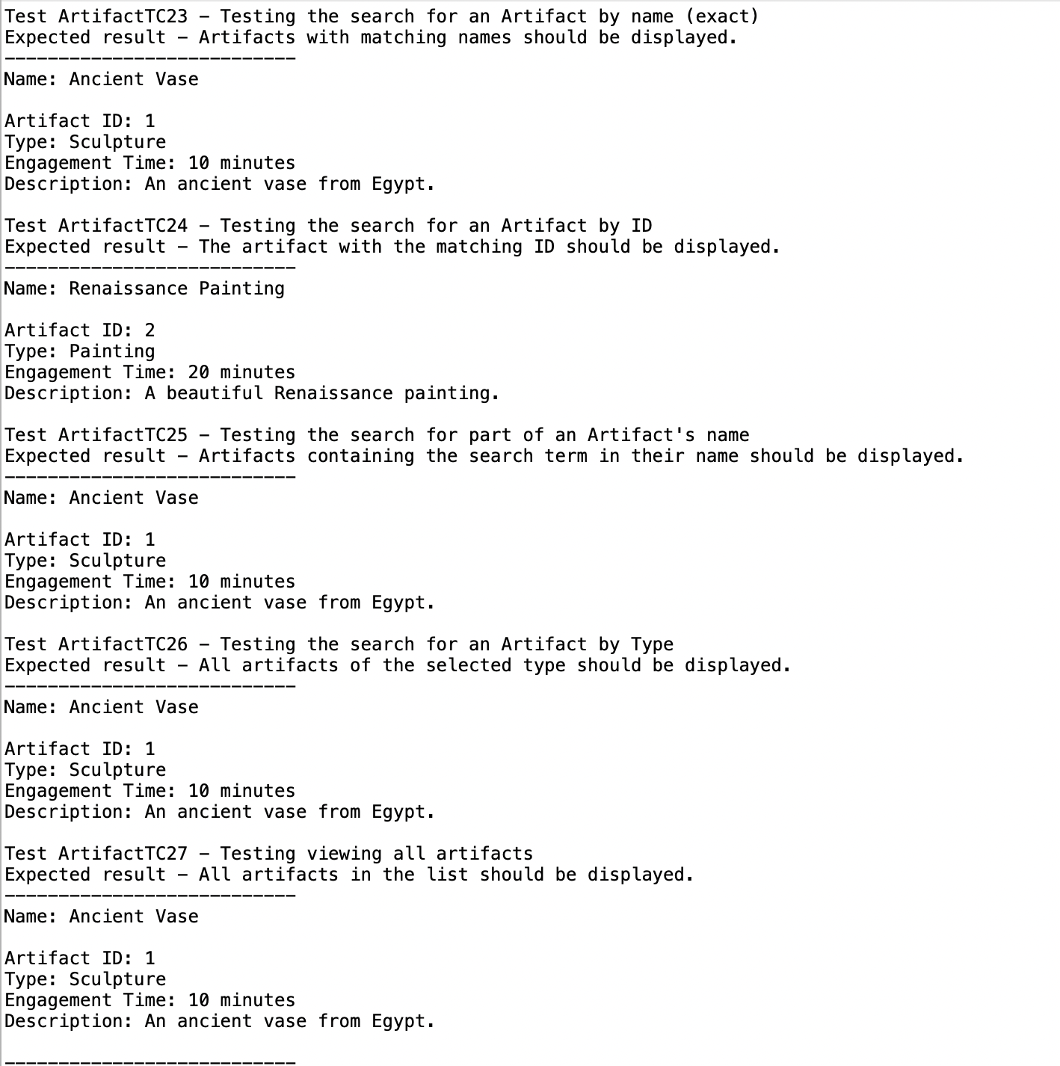

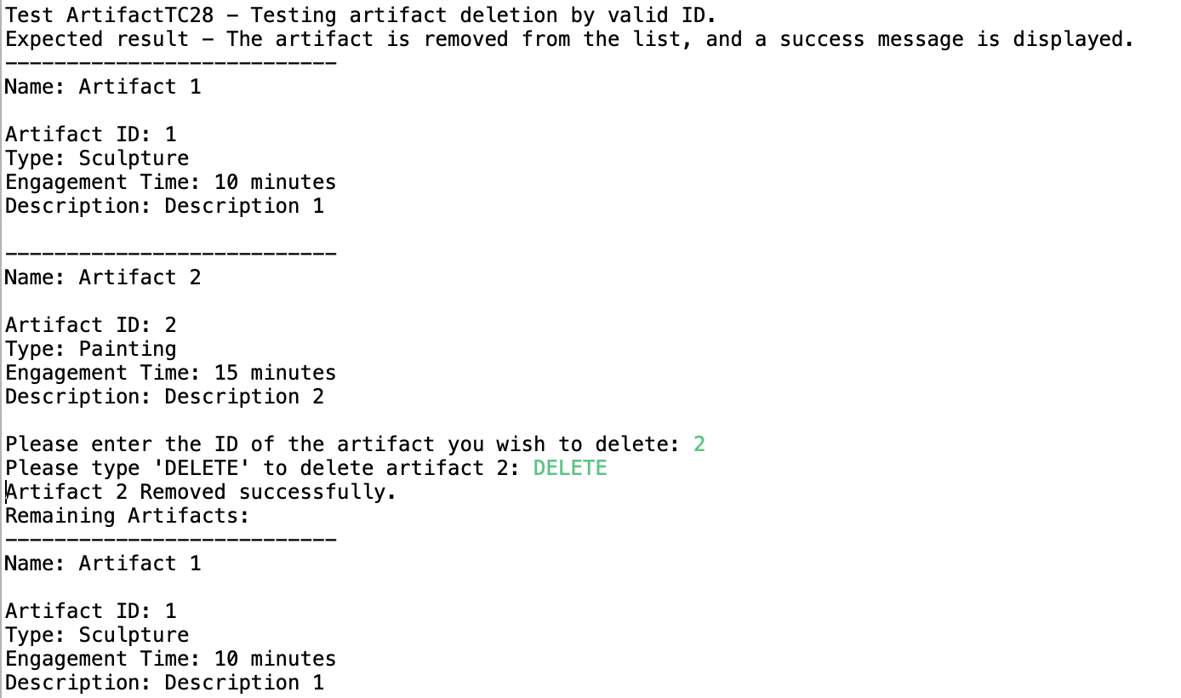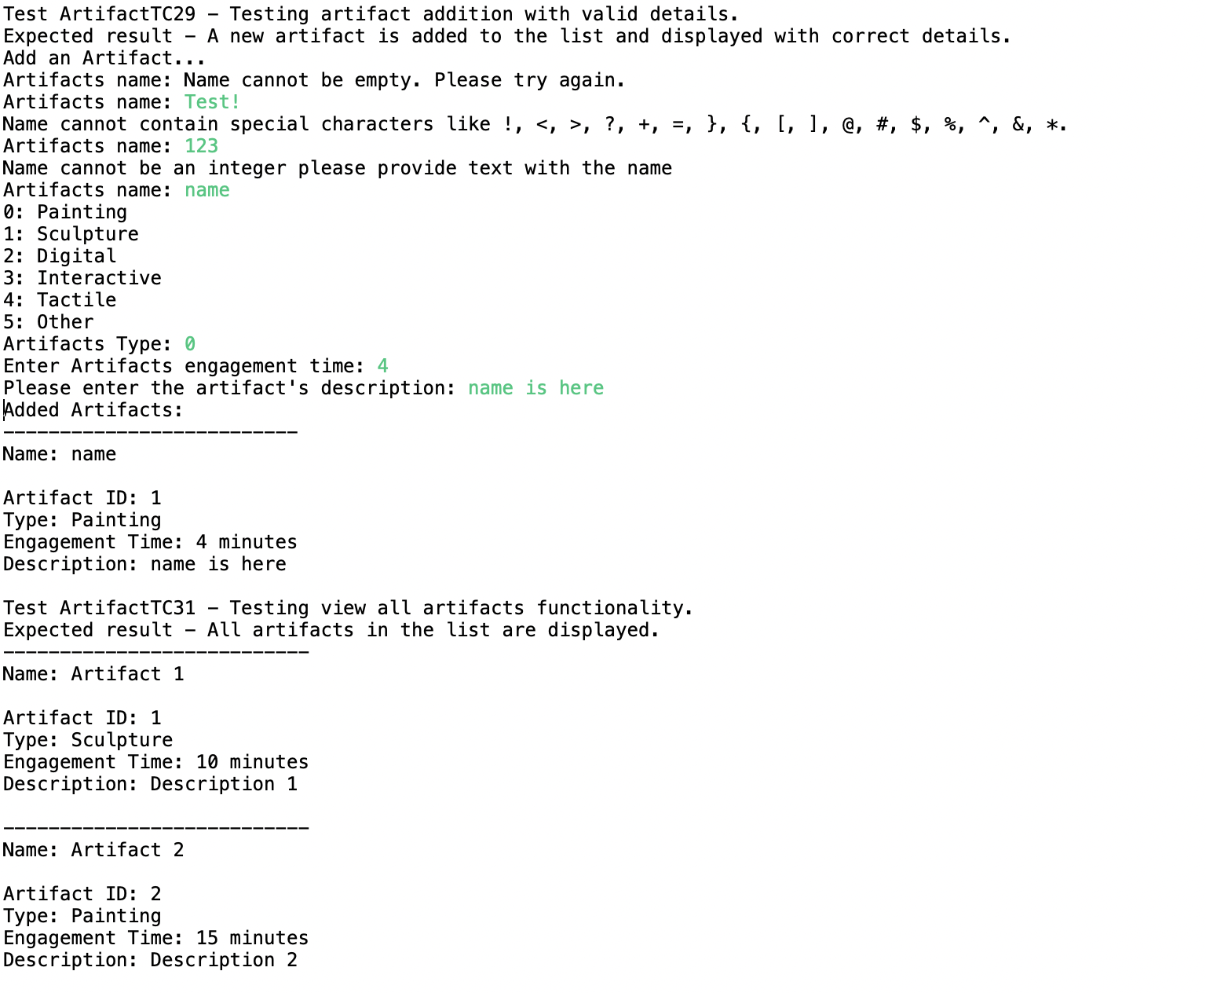

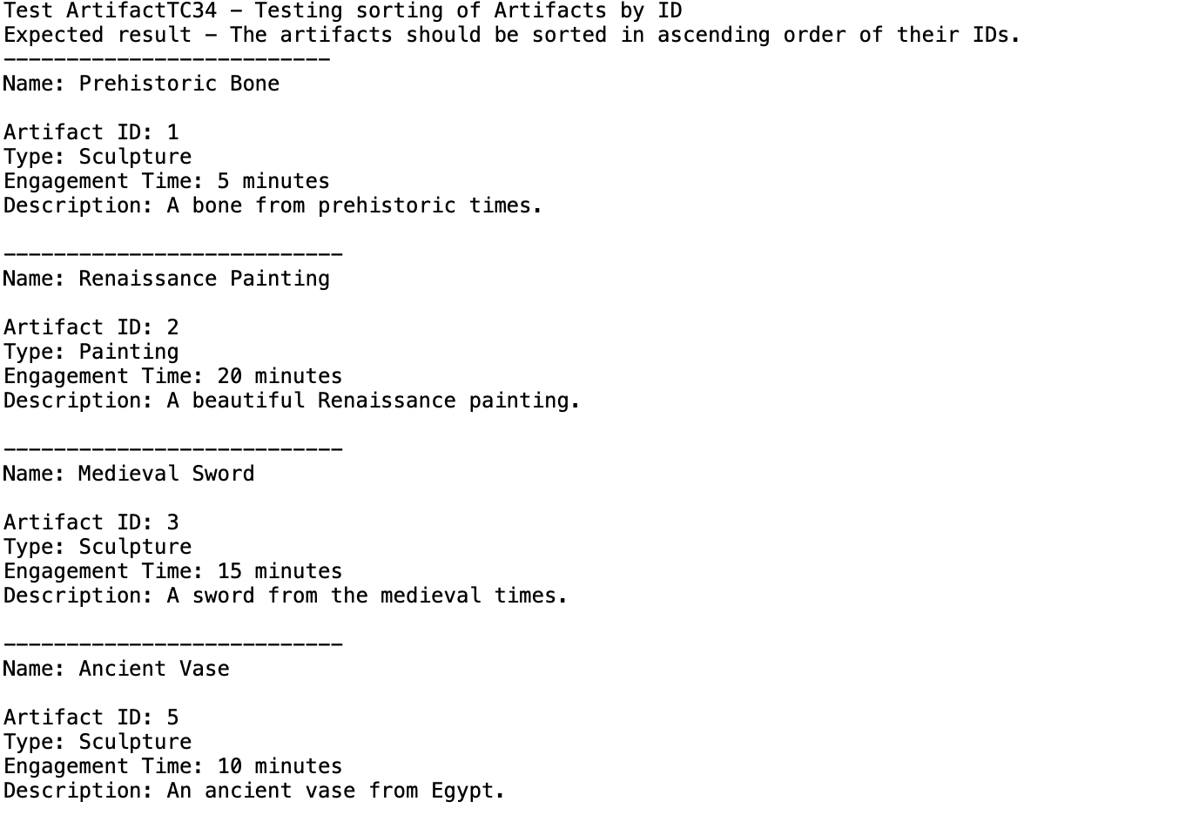

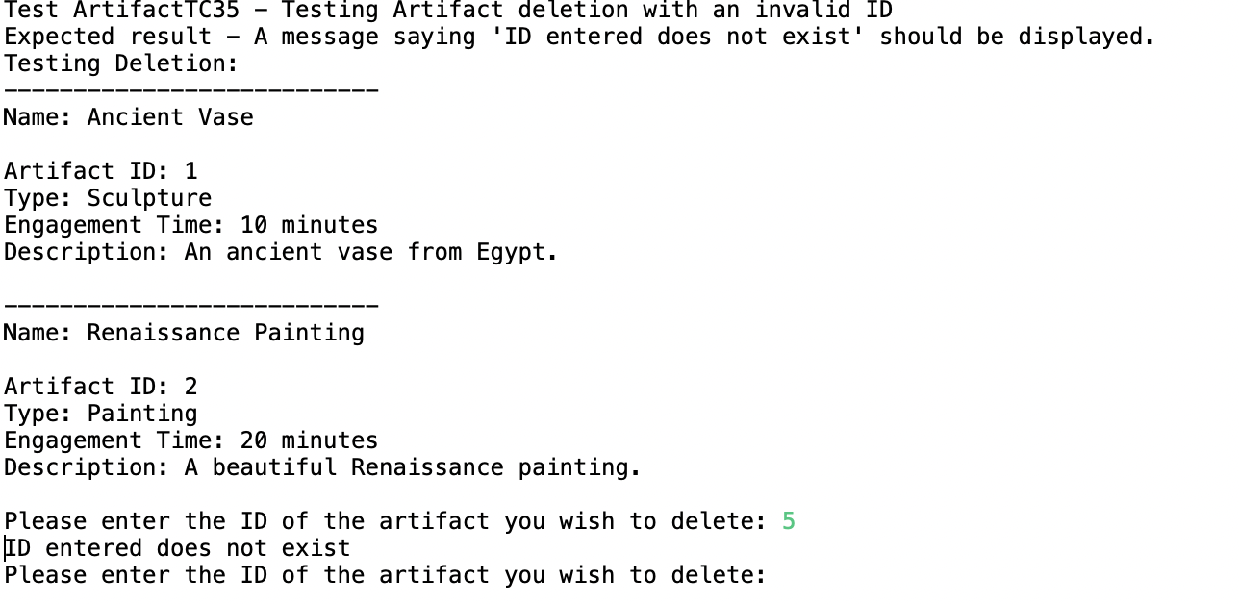

Artifact Type testing

This class is an enumeration class and hence there is a limited number of methods as there does not need to be much functionality. It simply defines the 5 possible artifact types for the user to pick from. There really isn’t much to test from in this class.

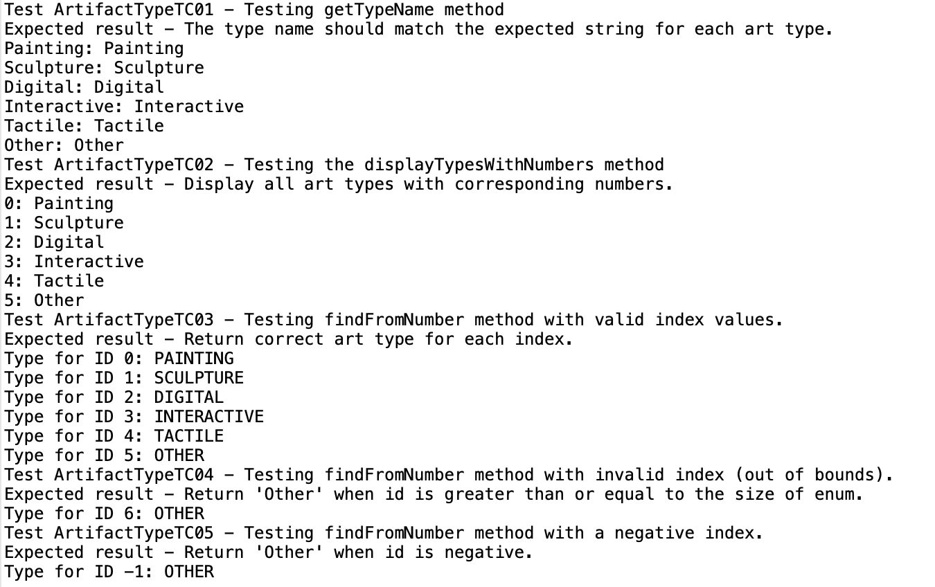

Exhibits Testing

For reference, each exhibit can have multiple artifacts added to the exhibit. An exhibit should have a name, description, id and array list of artifacts inside each instance of an exhibit. The exhibits instances are all stored in an array list which makes the testing easier to understand.

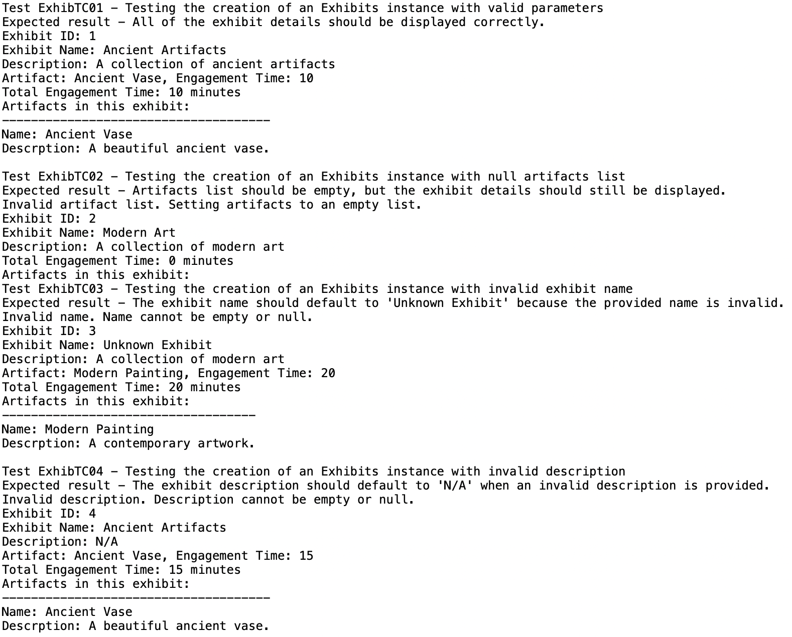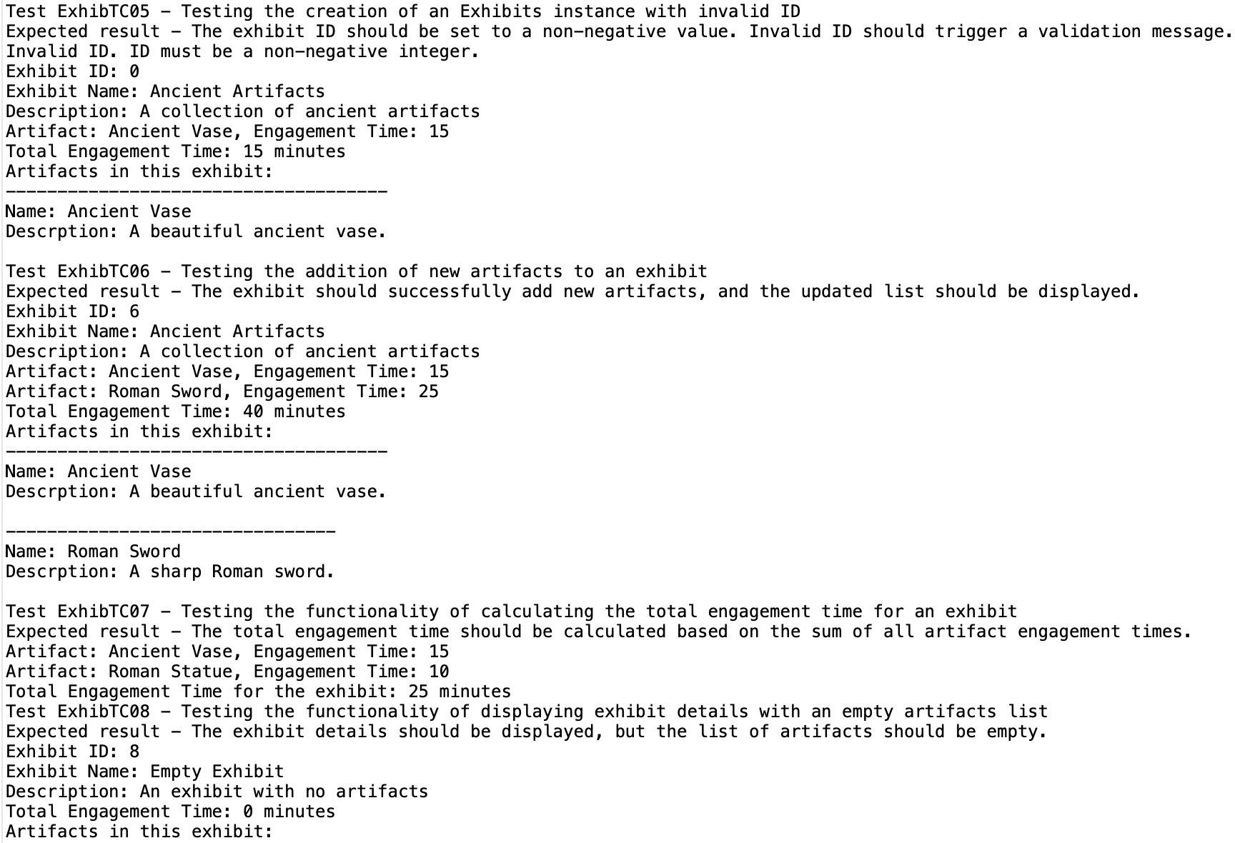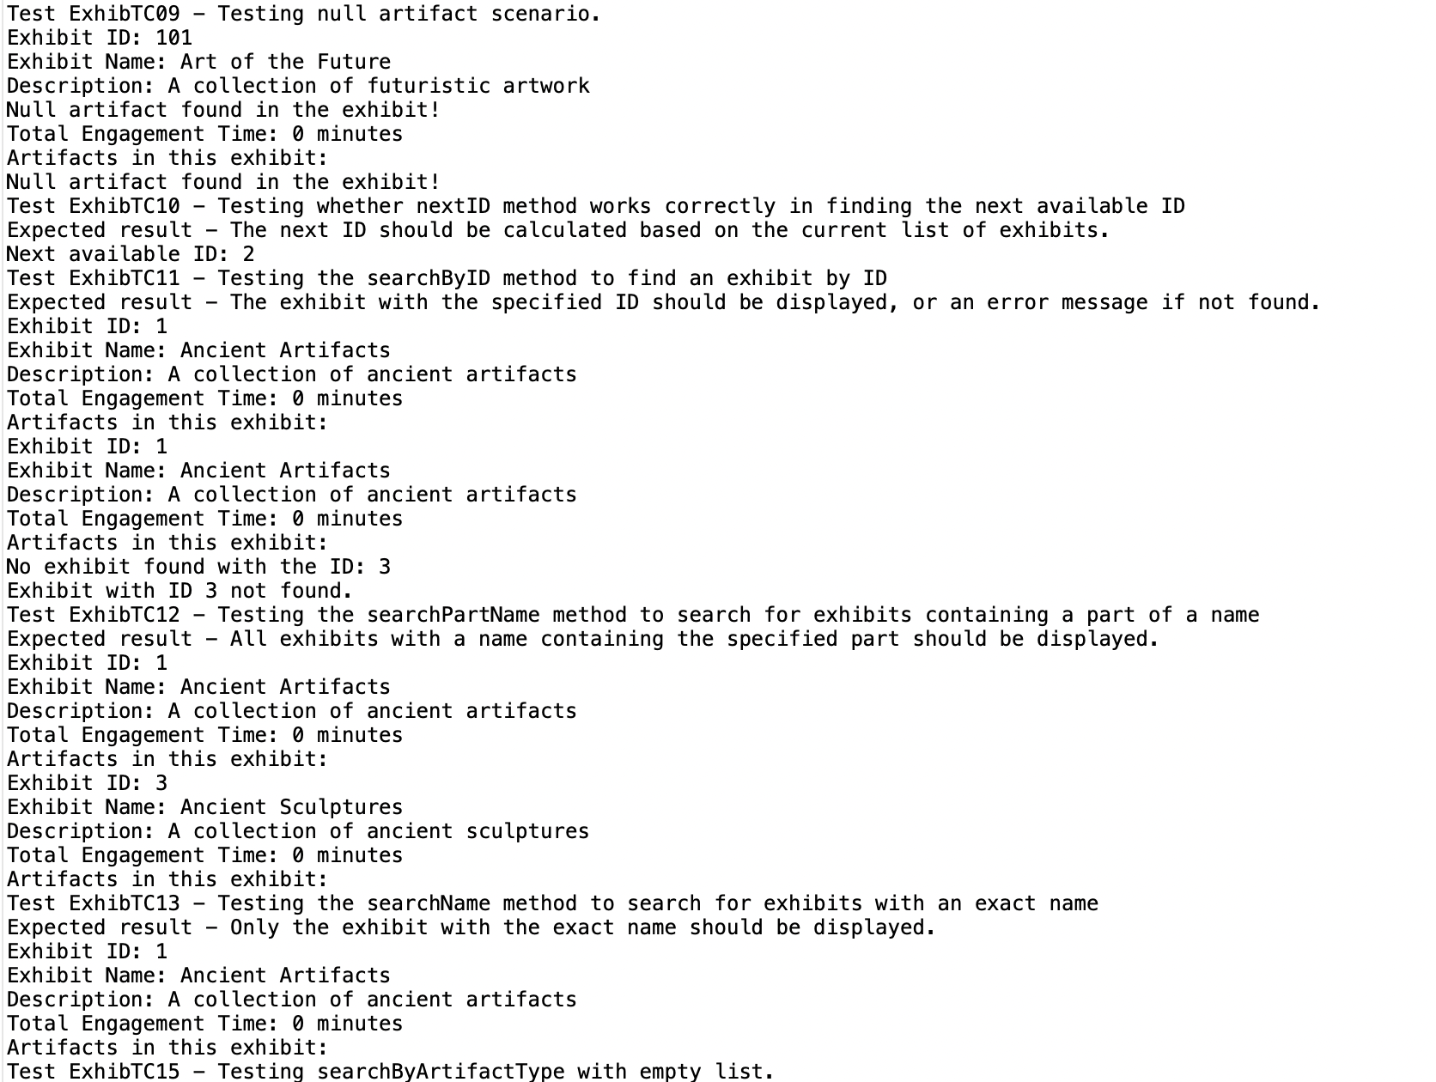

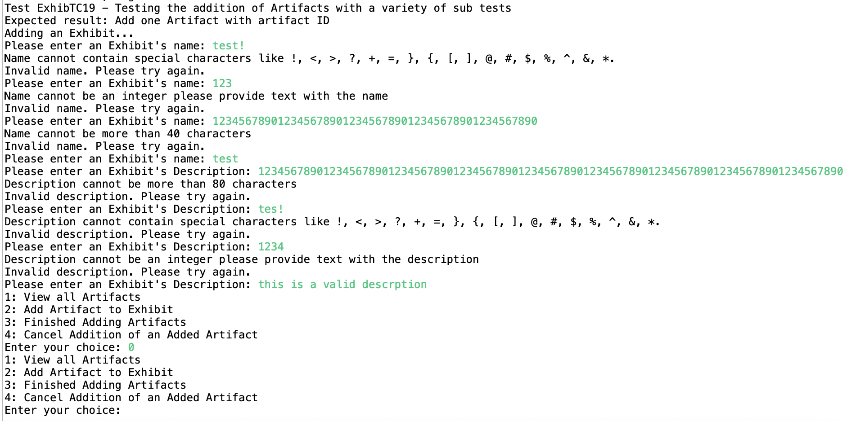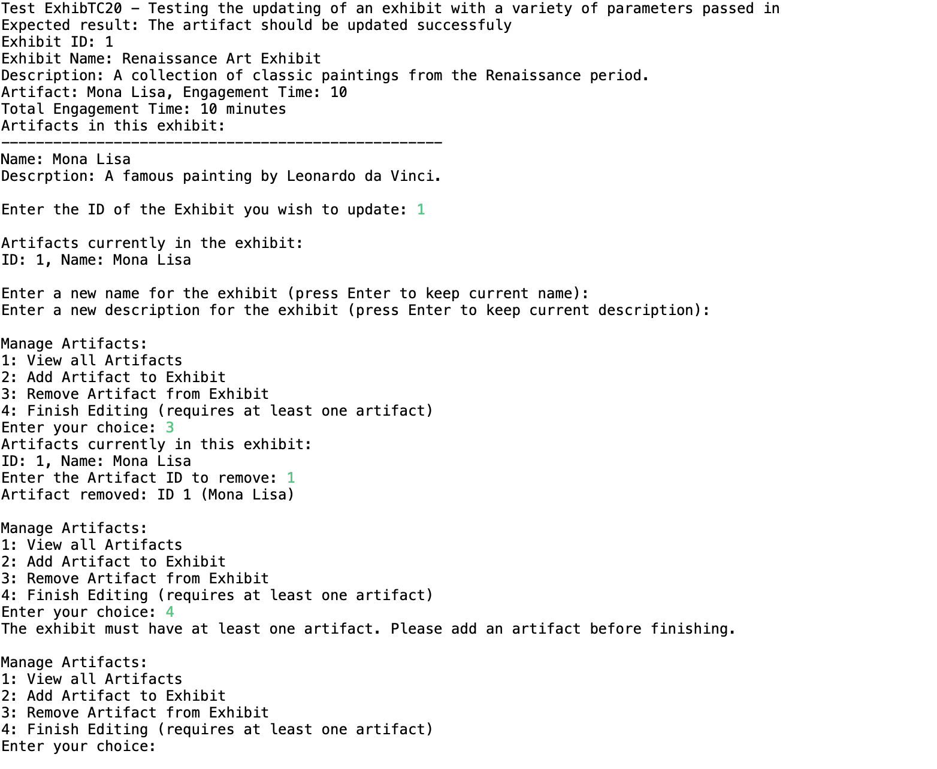

Route testing, each artifact in an exhibit should have a route number and description, this class allows this to occur in the system.

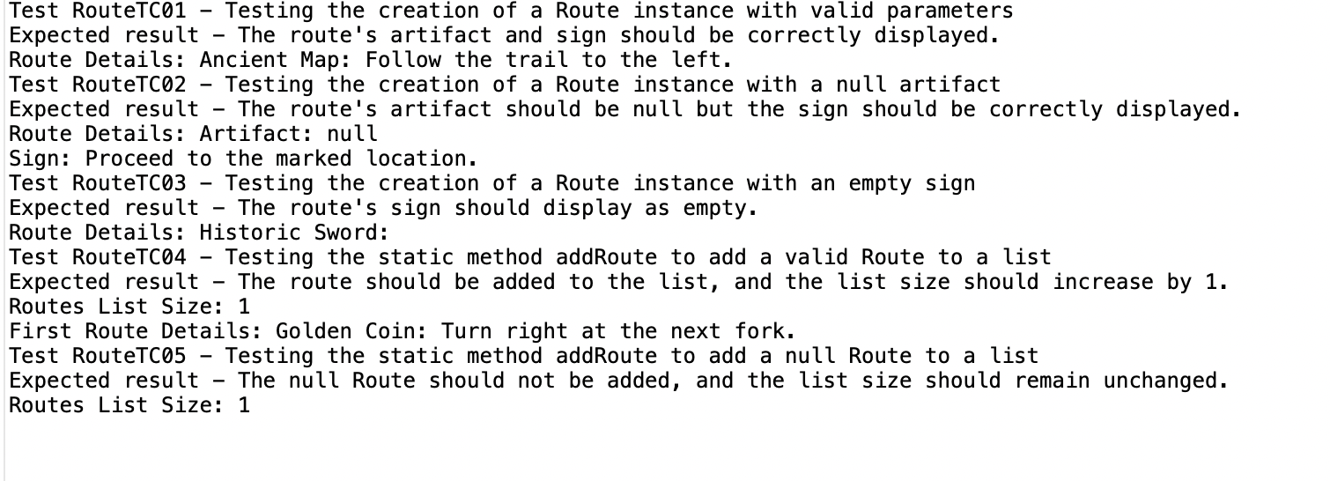

Validations testing

These validations are used throughout the system specifically in the artifacts and exhibits class. They ensure the name and description the user has entered is valid and correct.

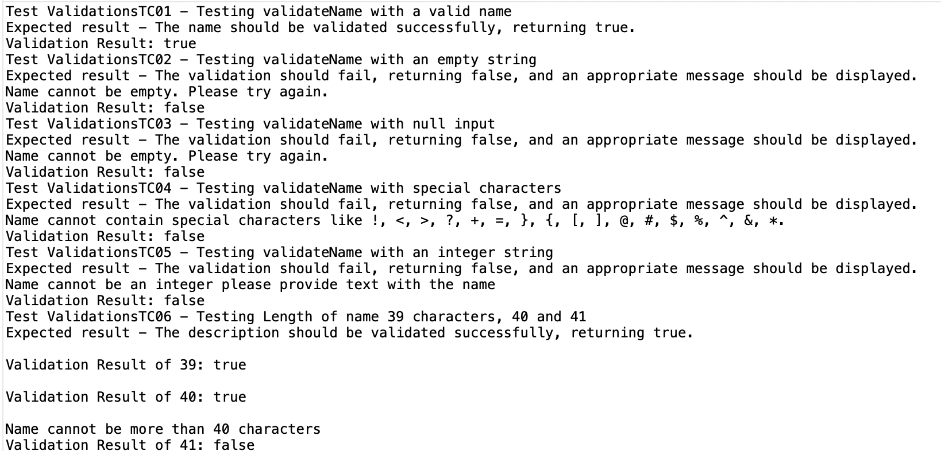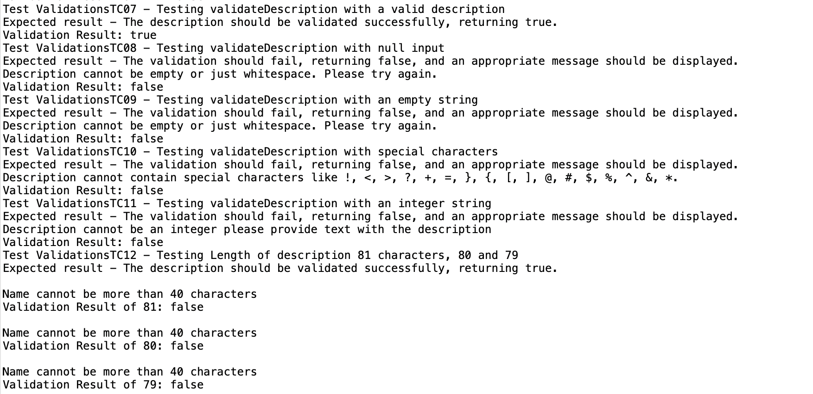

Comments about testing.

As the testing occurred, I found that some of the tests started to become repetitive as in the exhibit name and artifact name used the same validations and so was it necessary to retest this? I would also like to add that most of the manual tests were conducted multiple times during the creation of the project.